Children Can Learn a Language at the Library with KidSpeak™
You’ve heard it before and it’s worth hearing again: the best time to start learning a new language is as early as possible. The cognitive benefits of bilingualism pay off into adulthood.
For children whose parents do not speak another language and whose school district doesn’t offer languages at the earliest grades, there is now a viable alternative for starting a language early: the library!
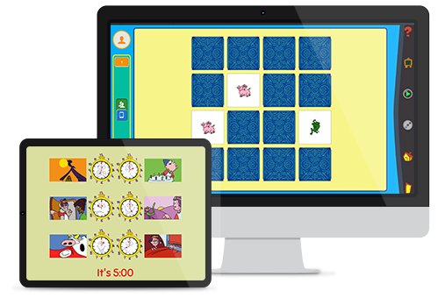
The library already offers language learning for elementary-to-adult level learners in Transparent Language Online. We’re happy to announce that now includes KidSpeak™, a fun, age-appropriate online language course designed for ages 6 and up!
All you need is a library card to introduce your children to English, Spanish, French, Italian, and Mandarin Chinese. The program teaches words and phrases suitable for learners’ age, needs, and interests. (No “I’d like a glass of wine.” in this course!) More than 40 activities, puzzles, and songs guide young learners through the basics, along with a cartoon “friend” who speaks the language.
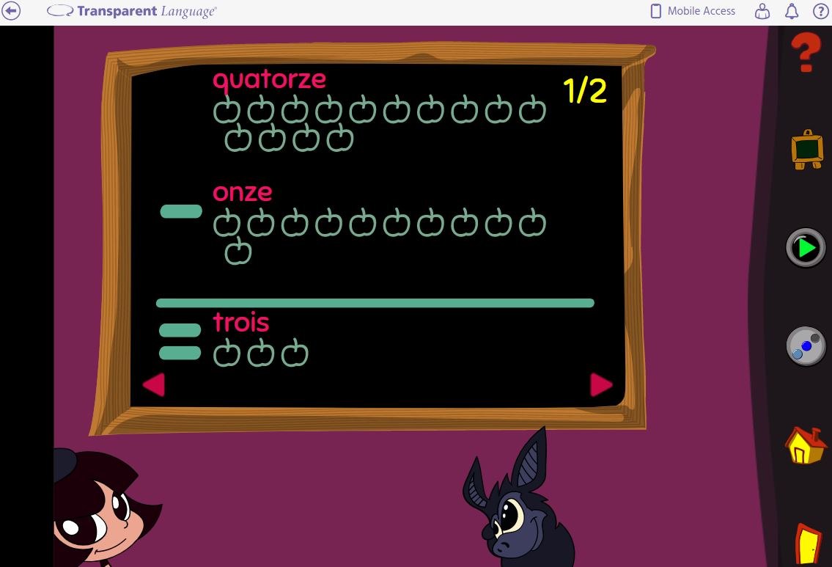
Using the successful immersion approach preferred for young children, KidSpeak™ introduces the alphabet and word recognition, simple sentences, how to use plural and singular, how to distinguish between words that look and sound similar, simple addition and subtraction, how to tell time, number recognition (matching numbers to written words), and correct pronunciation.
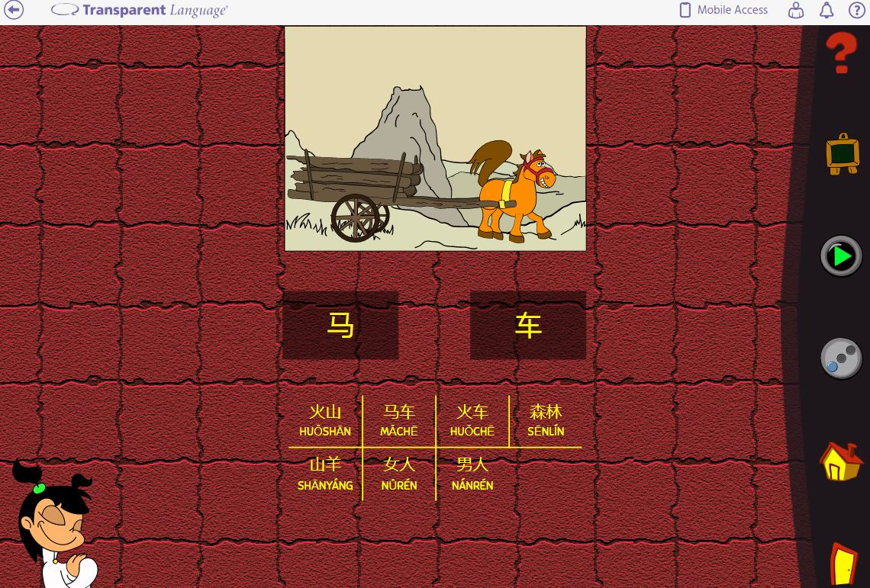
Best of all, your child can learn from anywhere (once you’ve signed up at the library, of course!) KidSpeak™ can be used through a web browser on computers.
To learn more about KidSpeak™ or Transparent Language Online, give us a call or swing by your local branch to get started!

